Water Jug Problem
Aim
To solve the Water Jug Problem using Artificial Intelligence state-space search.
Objective
To obtain the desired quantity of water using two jugs of different capacities.
Algorithm
- Start with both jugs empty.
- Fill one jug completely.
- Transfer water from one jug to another.
- Empty a jug when necessary.
- Repeat until the target quantity is obtained.
- Stop when the goal state is reached.
Flowchart
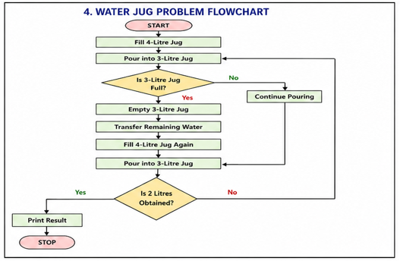

Sample Output
Water Jug Steps:
4L Jug = 4 3L Jug = 0
4L Jug = 1 3L Jug = 3
4L Jug = 1 3L Jug = 0
4L Jug = 0 3L Jug = 1
4L Jug = 4 3L Jug = 1
4L Jug = 2 3L Jug = 3
Python Code:
from collections import deque

def water_jug(a, b, target):
visited = set()
queue = deque([(0, 0)])

while queue:
x, y = queue.popleft()

if (x, y) in visited:
continue

visited.add((x, y))
print((x, y))

if x == target or y == target:
print("Target Achieved")
return

queue.extend([
(a, y),
(x, b),
(0, y),
(x, 0),
(min(a, x+y), y-(min(a, x+y)-x)),
(x-(min(b, x+y)-y), min(b, x+y))
])

water_jug(4, 3, 2)
Output:
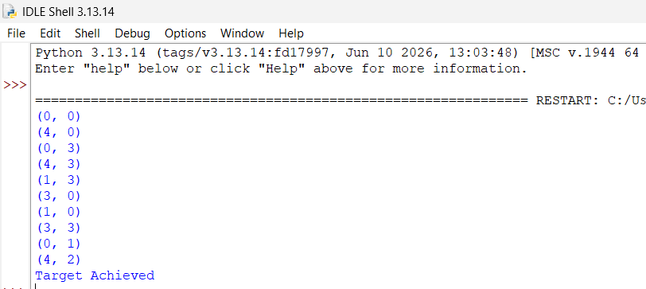
Result:
The target quantity of water was successfully obtained.
Conclusion:
The Water Jug Problem was solved using state-space search techniques.

